ps - The ps command in Linux is used to view running processes on your system
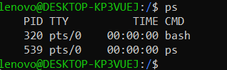
ps a - Print Active Running Process
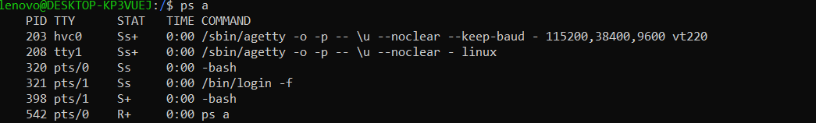
ping
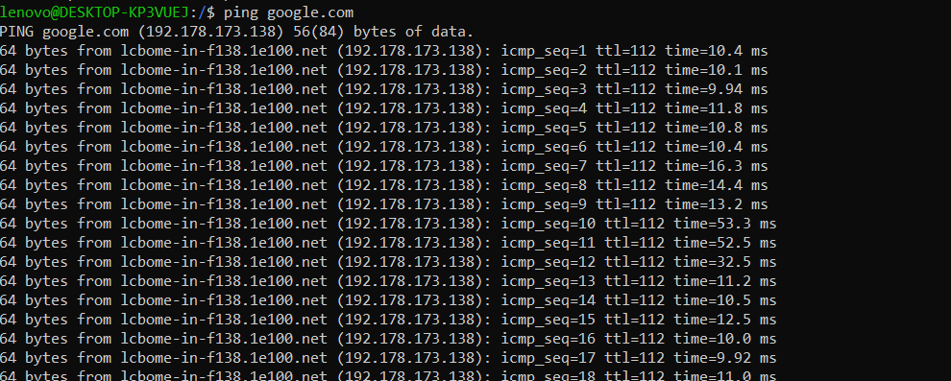

top - The top command in Linux is used to monitor system processes in real time (CPU, memory, running tasks, etc.)
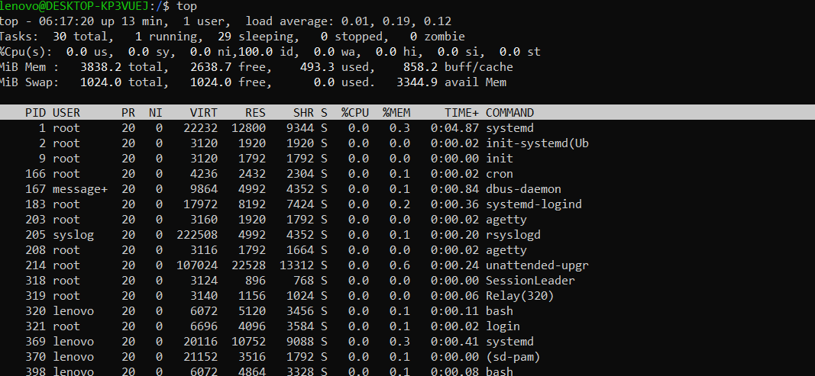
Service Commands
Systemctl status :
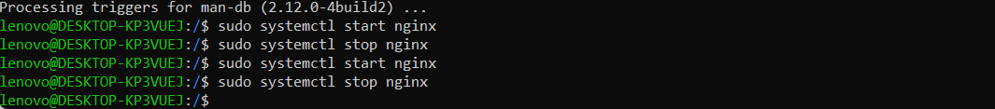
Log Commands:
1. View System Logs
Journalctl : Shows logs collected by systemd.
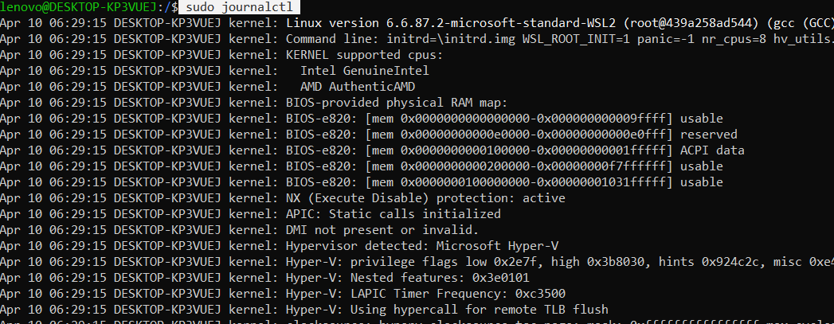
2. View Logs Live (Real-time)
journalctl -f:
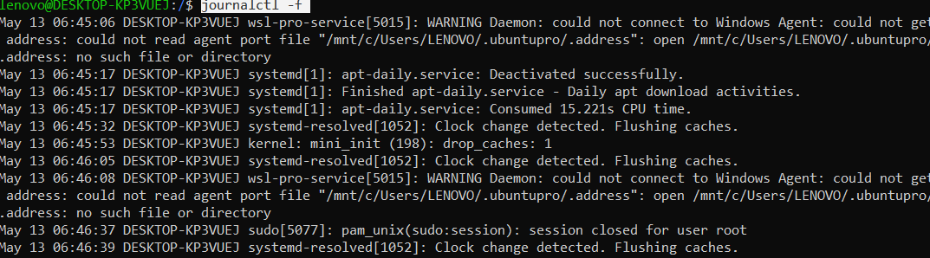
tail -f :live logs

3. Check Logs for a Specific Service
e.g - journalctl -u nginx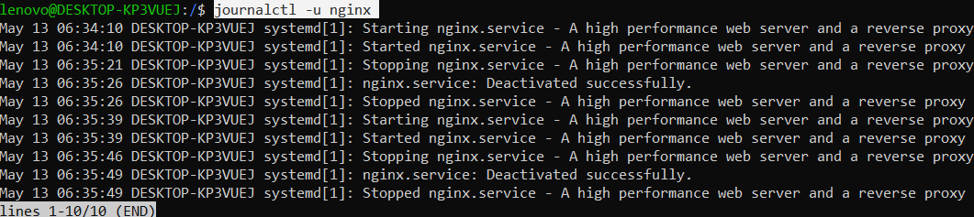

live logs: journalctl -u nginx -f

- tail -n <number> <file> - e.g . tail -n 20 abc.txt (Show last 20 lines)

